Given two binary trees original and cloned and given a reference to a node target in the original tree.

The cloned tree is a **copy of** the original tree.

Return *a reference to the same node* in the cloned tree.

**Note** that you are **not allowed** to change any of the two trees or the target node and the answer **must be** a reference to a node in the cloned tree.

**Follow up:** Solve the problem if repeated values on the tree are allowed.

**Example 1:**

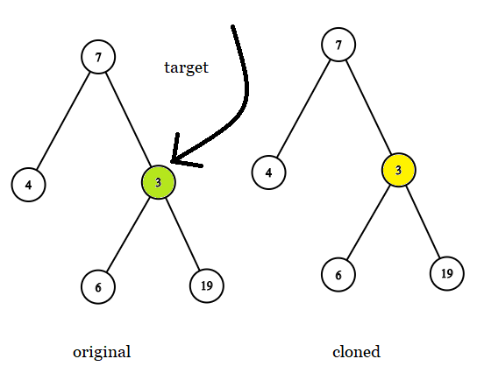

**Input:** tree = [7,4,3,null,null,6,19], target = 3

**Output:** 3

**Explanation:** In all examples the original and cloned trees are shown. The target node is a green node from the original tree. The answer is the yellow node from the cloned tree.

**Example 2:**

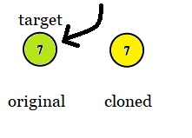

**Input:** tree = [7], target = 7

**Output:** 7

**Example 3:**

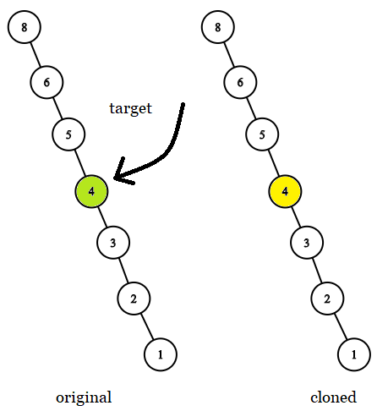

**Input:** tree = [8,null,6,null,5,null,4,null,3,null,2,null,1], target = 4

**Output:** 4

**Example 4:**

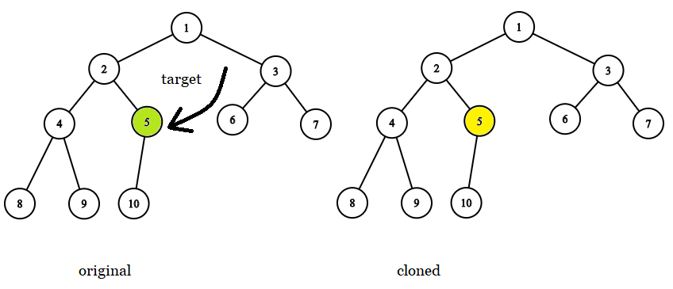

**Input:** tree = [1,2,3,4,5,6,7,8,9,10], target = 5

**Output:** 5

**Example 5:**

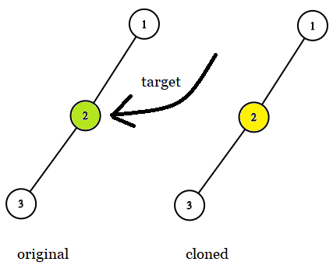

**Input:** tree = [1,2,null,3], target = 2

**Output:** 2

**Constraints:**

* The number of nodes in the tree is in the range [1, 10^4].
* The values of the nodes of the tree are unique.
* target node is a node from the original tree and is not null.